Results for Resnet with Step of 0.1 @ 100epochs
Training was set up to train models using the Adam optimiser over the lr 1e-5 to 5e-5 with a step of 0.1, The models where trained with a batch size of 8 over 150 epochs

Backbones | mAP 1e-5 step to 1e-6 | mAP 5e-5 step to 5e-6
Resnet 50 | 0.474 | 0.586
Resnet 34 | 0.512 | 0.553
Resnet 18 | 0.495 | 0.545

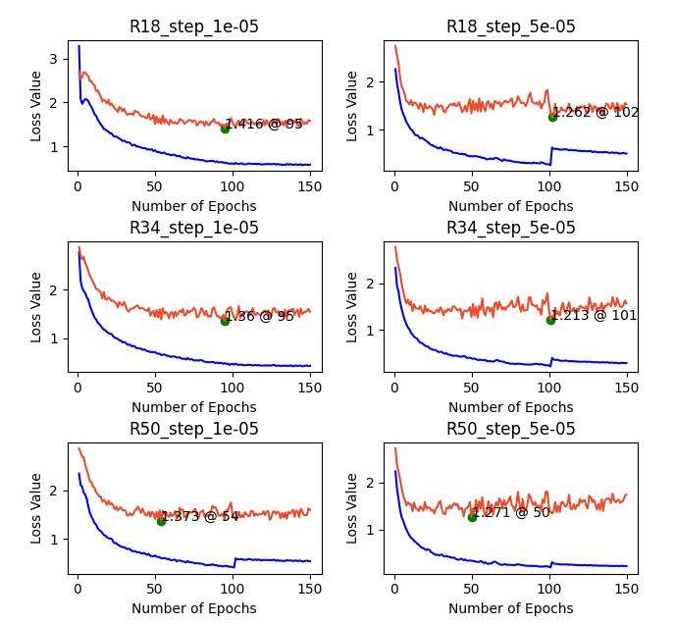
Sumary of results
Only two best model where found post step. Resnet 18 and 34 at 5e-5. All other epochs best models where found before the step. This may change when mAP values are used to select the model as opposed to the validation loss.

Higher Batch Size 4 to 8
Previous experiment trainig models with batch sizes 1-4 but could not be trained furthed due to gpu usage. The following two models where trained when gpu memory was available to compare the effect of a batch size from 4 to 8. The models where trained in the same manner as in the other experiment with the SGD optimiser and an LR of 0.01.

Backbone | mAP Batch size: 4 | mAP Batch size: 8
Resnet 50 | 0.545 | 0.550

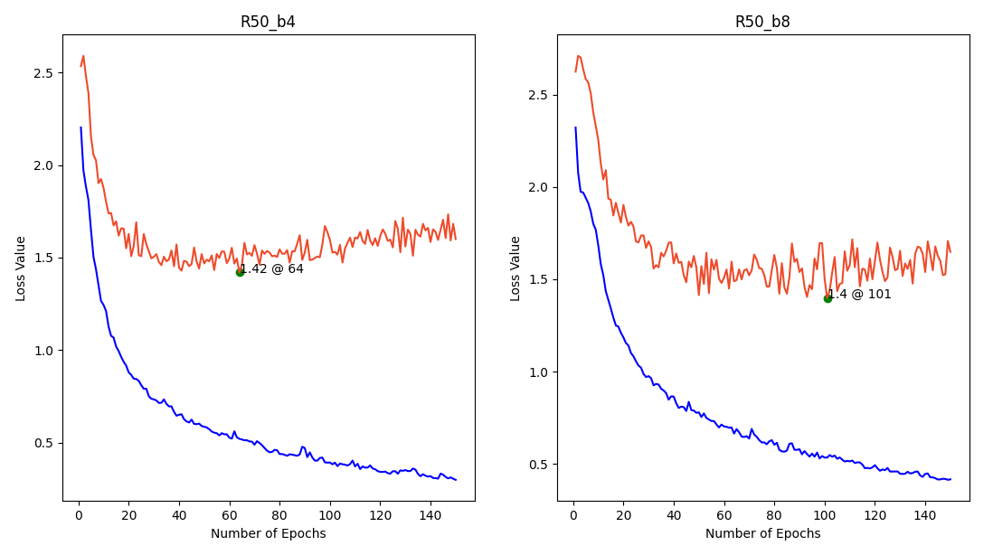
Summary
The higher batch size results in a higher mAP and the model being found at a larer epoch than with the lower learning rates

MobileNetv3 small adam optimizer with lr 1e-6 to 5e-5

The models where trained over a range of four learning rate found to be effective for the resnet backbones. A batch size of 8 was used for all models in training

Backbone | mAP LR: 1e-6 | mAP LR: 5e-6 | mAP LR: 1e-5 | mAP LR: 5e-5
MobileNetv3 | 0.067 | 0.190 | 0.210 | 0.281

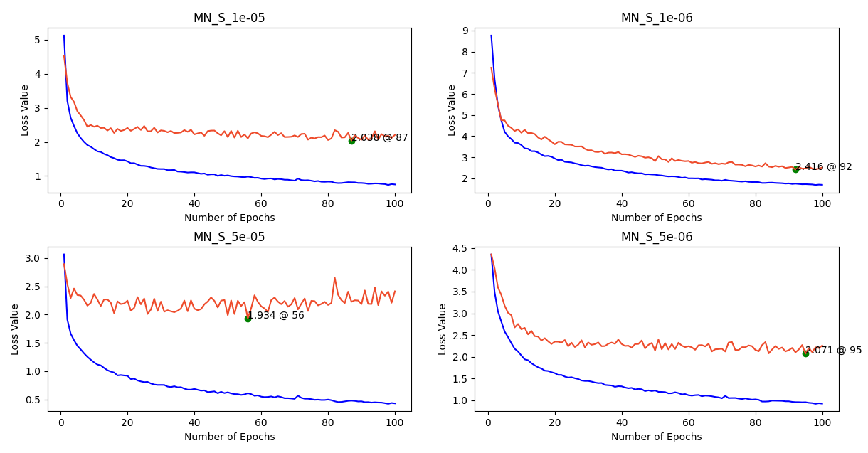
Summary
The plot for 1e-6 appears to need further training. The model should be re loaded trained further. The lr 5e-5 proves to yeild the best learning rate.

